Rice Krispie Treats

Ingredients
- 3 tablespoons butter
- 4 cups Miniature Marshmallows
- 6 cups Kellogg's® Rice Krispies® cereal

Directions
1. In large saucepan melt butter over low heat. Add marshmallows and stir until completely melted. Remove from heat.
2. Add Kellogg’s Rice Krispies cereal. Stir until well coated.
3. Using buttered spatula or wax paper evenly press mixture into 13 x 9 x 2-inch pan coated with cooking spray. Cool. Cut into 2-inch squares. Best if served the same day.
Nutrition Information
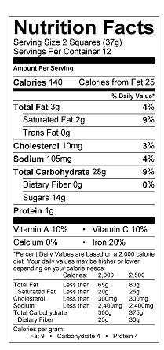
Proportional Relationships
in Baking Project
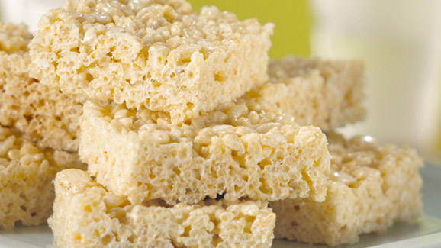

Group Names ____________________ Date ________

Directions: Answer the following questions as a group using your knowledge of proportional relationships and the constant of proportionality.

1) Mr. Scott and Mrs. Seitz are comparing prices before buying Rice Krispies cereal. Help them
find the best deal. Rice Krispies cereal costs $11.92 for 4 boxes at Walmart, and $7.78 for 2
boxes at Wegman’s.

a) Create a table to compare the number of boxes of cereal to the cost for 1, 2, 3, 4, and
5 boxes at each grocery store:
Walmart: Wegman’s:
Number of cereal boxes | Cost  ($)
Number of cereal boxes | Cost  ($)

b) What is the unit price of Rice Krispies cereal at each store?
Walmart____________ Wegman’s _____________
c) Which is the better deal? Explain why.
____________________________________________________________________
____________________________________________________________________
____________________________________________________________________

d) Write a rule for each table.
Walmart ______________ Wegman’s ______________

e) What is the constant of proportionality and what does it mean in this situation?
____________________________________________________________________
____________________________________________________________________

2) Using your recipe, we must figure out how much of each ingredient we need.

a) Create tables that show how much butter (in tablespoons), marshmallows (in cups),
and Rice Krispies cereal (in cups) you will need to make one, two, three, and “x” batches of
Rice Krispie Treats:
# of batches | Rice Krispies  (cups)
x
# of batches | Butter (tbsp.)
x

# of batches | Marshmallows  (cups)
x

b) Is the amount of butter proportional to the number of batches? ____________
If yes, what is the constant of proportionality? ___________
Write a rule that relates the number of batches to the amount of butter needed. _________________

c) Are the cups of marshmallows proportional to the number of batches? ___________
If yes, what is the constant of proportionality? ___________
Write a rule that relates the number of batches to the cups of marshmallows needed. _________________

d) Are the cups of Rice Krispies proportional to the number of batches? ___________
If yes, what is the constant of proportionality? ___________
Write a rule that relates the number of batches to the cups of Rice Krispies needed.
_________________

3) Now let’s explore whether there are proportional relationships between the ingredients. The
table below compares the number of cups of marshmallows to the number of cups of Rice
Krispies.

a) Find the missing values in the table below:
Marshmallows (cups) x | 4 | 6 | 8 | 10
Rice Krispies (cups) y | 6 | 9

b) Is the amount of marshmallows used proportional to the amount of Rice
Krispies? __________
If yes, what is the constant of proportionality? ____________
Write a rule that relates the cups of Rice Krispies to the cups of marshmallows.
________________

c) If we have 11 cups of marshmallows, do we have enough to make 3 batches of Rice
Krispie Treats? _________
If not, how many batches could we make? __________

d) If we have 16 cups of marshmallows, how many batches could we make? __________
How many cups of Rice Krispies do we need to make that many batches? __________

e) Plot the ordered pairs from the table on the graph below. Make sure to label your x
and y-axes:
y
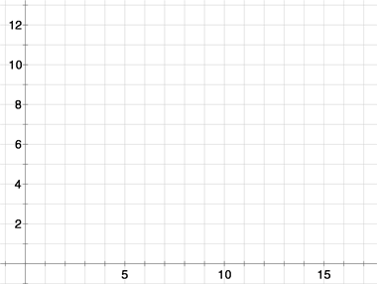

x

f) Does the graph show a proportional relationship? ___________
Explain how you know. _________________________________________________________
____________________________________________________________________________
____________________________________________________________________________

g) What point on the graph shows the unit rate? ( , )
What does it mean in this situation? ______________________________________________
____________________________________________________________________________

4) Now that we’ve made our Rice Krispie Treats, we need to figure out how to distribute them equally
between the students (and teachers, of course!).
a) If we have 10 math students and 2 teachers, How many different ways can we divide the Rice
Krispie Treats equally using one batch (one 9 x 13 inch pan)? __________

How many would each person receive using each method? _________________________
_________________________________________________________________________

b) How many different ways could we divide them equally using 2 batches? __________

How many would each person receive using each method? ___________________________
___________________________________________________________________________

c) How many different ways could we divide them equally using 3 batches? ___________
How many would each person receive using each method? ____________________________
____________________________________________________________________________

5) If we cut one 9 x 13 inch pan into 24 squares, and each person ate 4, how many grams of fat would
each person consume? _____________
How many grams of sugar? _____________
What percentage of iron? _____________

6) Now it’s time to eat them. Enjoy!

