Directions for photoshop

To scan your template: Mrs. Seitz did this for you…
- Place your template face down on the scanner.
- Go to the Start menu → Programs → Adobe PhotoShop Elements 5.0
- Select “Edit and Enhance Photos”
- Select File → Import → HP ScanJet 3500c
- Select Preview. Then look at the image to make sure all of your template is on the screen. If it looks good, choose “Accept.”
To Begin:
- Log onto a computer.
- Click on Computer.
- Find your name and click on it (this is your H Drive).
- Click on “New Folder.”
- Name it “Math.”
- Log onto your school email.
- Open the email from Mrs. Seitz, and double click on the attachment (this is your template).
- Choose “Save As”, and save this into your math folder on your H Drive, naming it “Your Name Template” (ex. “Meghan Seitz Template”).
- Log out of your email.

To open your template in PhotoShop:
- Go to the Start Menu (bottom left), Select “All Programs,” and then “Adobe PhotoShop Elements 5.0” (at the top of the list).
- Choose “Edit and Enhance Photos.” If boxes pop up, answer “No” or “Later.”
- Select File → Open.
- Click on Computer, Click on your name (H Drive), Click on Math Folder.
- Double click on Your Template.
- When it opens in PhotoShop, change Resolution to 150 (if it asks).

To start a new document (within PhotoShop):
- Select File → New → Blank File
- Name it: “Your Name Tessellation” (ex. “Meghan Seitz Tessellation”)
- Choose Resolution : 150
- Choose Size: Width= 8.5 and Height= 11 inches

To eliminate white space around your shape:
- Choose Magnetic Lasso Tool by right clicking on the sixth icon down on the left side (lasso rope with little red magnet), and use this tool to select your image.
- Trace around the outside of your shape and click often as you go, until you have gone all the way around and connected to the point you started at.
- When your outline starts flashing, Choose Edit → Copy and then Edit → Paste.
- Move off of the Lasso Tool and select the Move Tool (1st icon on the top left).

To begin tessellating your shape on the page:
- Left click on your shape and drag it onto the 8.5 x11 new file you created and named. Then let go of the mouse button.
- Adjust the size of your shape to make it smaller (at least 4 or 5 of your shape should fit across the page).
- Make a few copies by selecting Layer → New → Layer Via Copy (Do this 3 or 4 times).
- Drag them next to each other like puzzle pieces.
- Begin using the Paint Bucket Tool and filling your shapes with various colors.
- Make sure you choose different colors for each of the first copies of your shape.
- After you have colored these in, copy them and drag them next to each other until you fill the entire page (with colors alternating). There should be no white space.

To create a title:
- Click on the TEXT icon on the left side of your screen “T” (9th icon from the top).
- Click on your project where you want the text to appear.
- In the top toolbar, choose a font style, size, and color (Make sure your color will stand out against the colors in your tessellation).
- Type the name of your tessellation.
- Drag the Text layer to the top, so it can be seen.
- Now repeat these steps and include a line that says “By (your name) .
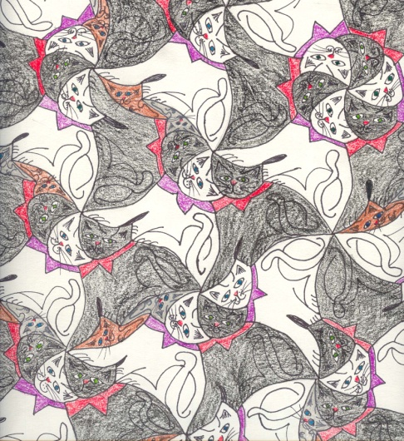
- Both your title and credit text should be at the top or bottom of your project (not in the middle, where it blocks the main part of your design).

