Name ______________________ | Mr. Amidon | Science 8
Mitosis & Meiosis
Complete the following questions. Use your notes, the attached diagrams and the web sites below as references.
Web Sites: (Can be accessed through “Mitosis-Meiosis Webquest” on Mr. Amidon’s Homepage.
Cell Division: Binary Fission and Mitosis
Cell Division: Meiosis and Sexual Reproduction
Interactive Mitosis Tutorial (Requires the Shockwave plug-in, available from the site)
Mitosis (Illustration)
Meiosis (Illustration)
Comparison of Meiosis and Mitosis (Illustration)
- What is meant by the phrase "cell cycle"?
- What are the phases that make up the cell cycle?
- How does cell division occur in prokaryotes?
- What events must occur during cell division in both prokaryotic and eukaryotic cells?
- How does prokaryotic cell division differ from eukaryotic cell division?
- What is cytokinesis?
- What is meant by the terms diploid and haploid?
- What is the purpose of mitosis?

- Identify and describe each phase of mitosis.
- Draw diagrams that depict each phase of mitosis.
- How does cell division in animals differ from cell division in plant cells?
- What is the purpose of meiosis?
- Identify and describe each phase of meiosis.

- Draw diagrams that depict each phase of meiosis.

- What is gametogenesis?
- How many sperm cells are produced in males when one diploid cell enters gametogenesis?
- How many egg cells (ova) are produced in females when one diploid cell enters gametogenesis?
- Describe ways in which mitosis and meiosis are similar.
- Describe the ways in which mitosis and meiosis are different.
From: SAS® Curriculum Pathways® Copyright © 2011 SAS Institute Inc., Cary, NC, USA, All Rights Reserved
DIAGRAMS
http://www.emc.maricopa.edu/faculty/farabee/BIOBK/BioBookmito.html
http://www.emc.maricopa.edu/faculty/farabee/BIOBK/BioBookmeiosis.html
Images from from Purves et al., Life: The Science of Biology, 4th Edition, by Sinauer Associates (www.sinauer.com) and WH Freeman (www.whfreeman.com), used with permission.
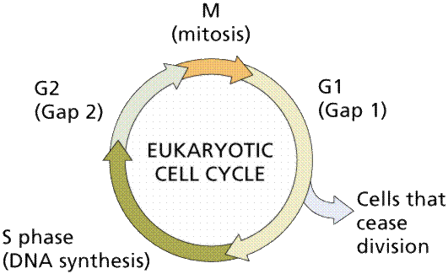  The cell cycle. | Structure of a eukaryotic chromosome.  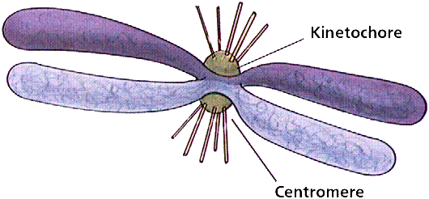
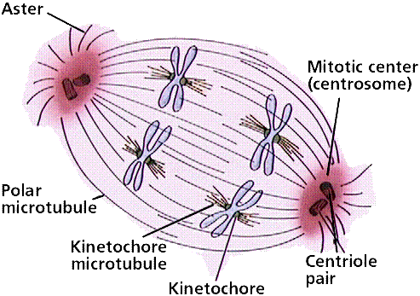 Structure and main features of a spindle apparatus. | Crossing-over between homologous chromosomes produces chromosomes with new associations of genes and alleles. 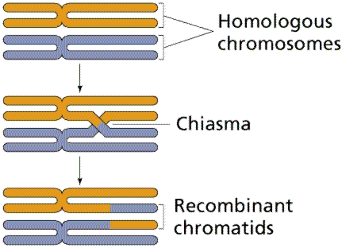

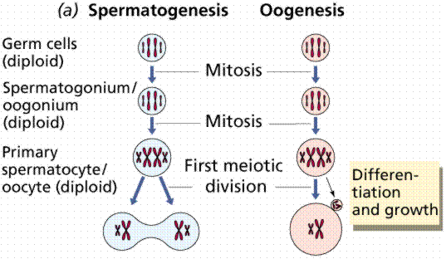
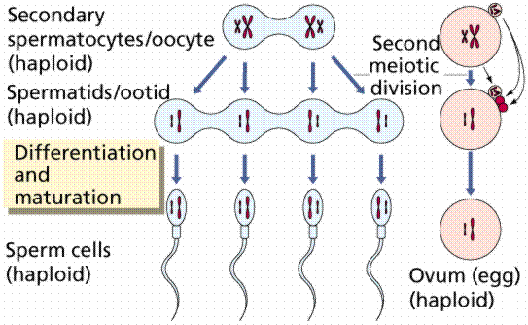
Gametogenesis. Images from Purves et al., Life: The Science of Biology, 4th Edition, by Sinauer Associates (www.sinauer.com) and WH Freeman (www.whfreeman.com), used with permission.
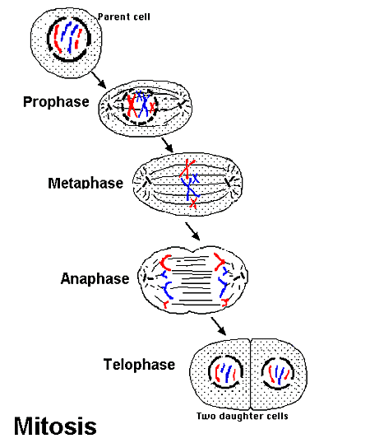 | 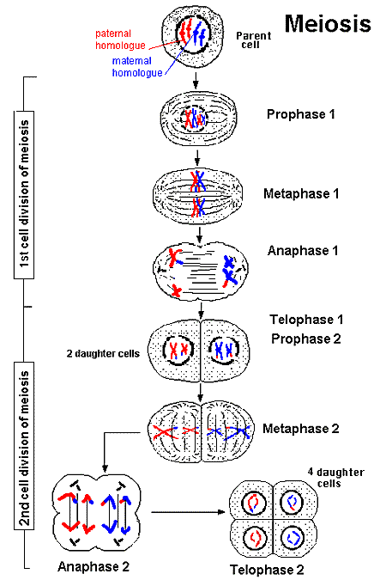
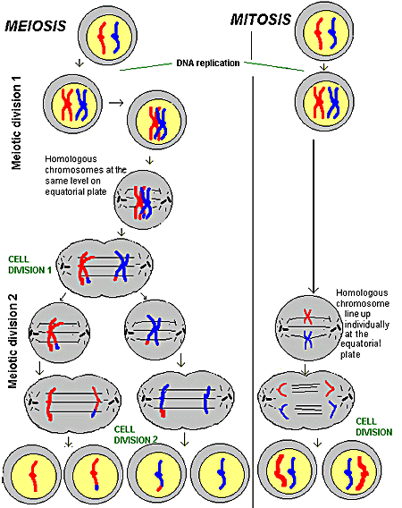
http://www.accessexcellence.org/RC/VL/GG/mitosis2.php, http://www.accessexcellence.org/RC/VL/GG/meiosis.php, http://www.accessexcellence.org/RC/VL/GG/comparison.php

