Dear GAPS,
I just wanted to thank you again for the money that you gave me to spend at the Penguin Publishers Warehouse Sale in Conklin, NY in mid-November. I was allotted $300 from you, of which, I spent $261. I was able to purchase 120 books with the $261. I also added up how much the books would have cost had I paid the regular retail price for all of them. The grand total? A whopping $1755.86! I paid approximately 15% of the regular retail price. Without the funds from you, I would not have been able to purchase anything at the warehouse because they do not accept purchase orders, and the LaFayette School District is unable to reimburse spending. So, thank you again for your donation to the library – it will have a huge impact on our ability to service the students of Grimshaw.
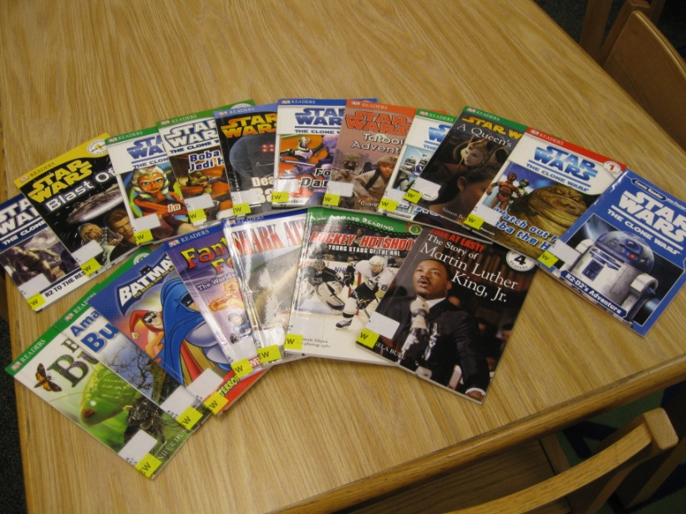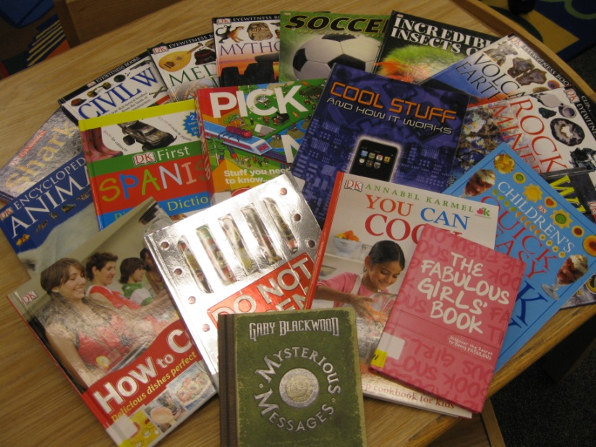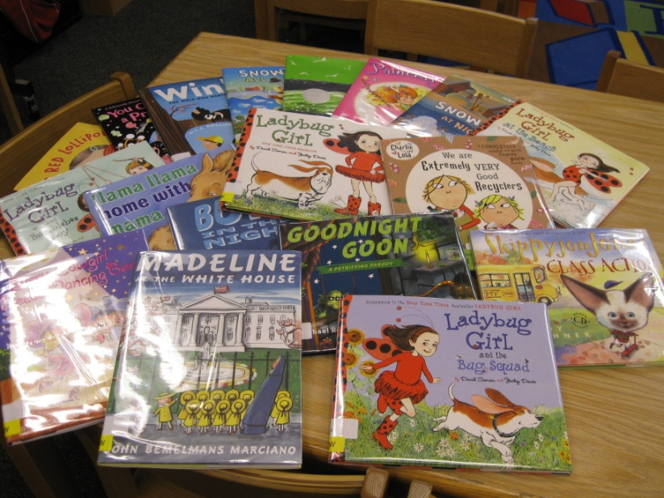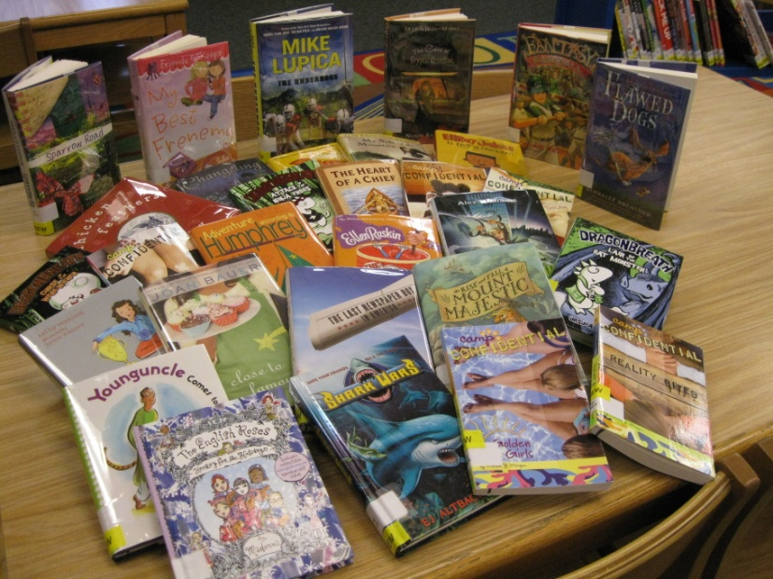
Attached is the receipt for the book, and here is the label that went on the inside cover of each book from the sale:

Again, thank you…
Sue Bang

